The Best Hairstyles “ENC” Contest Competition “100 Coaches” to Recruit, Starts May 1st

Air ‘Money, CEO Steven E Goodloe
ALL RIGHTS RESERVED
As an Independent Contractor
I will follow ALL Rules, and Applicable Laws.
Signature and Date _______________________________________________________________________

Welcome Letter To 100 ENC Best Hair Stylists “Coaches”
Congratulations to 100 Hair Stylist Coach. Our Company looks forward to working with you on this Team of 10,000 “Best Hair Styles” Contest Competition Contestants. We have Big “Payout” plans for each Coach, and we plan to have fun. This Project is Set to last up to One Year, from start to Finish.
As an Independent “Contract” Professional or Little Experience Hair Stylist Coach, your role is to Assist us in the Recruitment of 100 “Get My Hair Done Style” Contestants. Each Coach will have their own VIP Hair Show with a Custom-built Venue.
As a Hair Stylist Coach, you will make $400,000. Your 100 Contestants will each make $8,000 + $2,000 Luxury Gift Basket. Six of your Best ”Get My Hair Done Style” Contestants Will Win a “Grand Prize” of $100,000 Each.
There will be 16 “VIP” Grand Prize Winners, chosen from all 100 Teams. Each VIP Winner will receive a Grand Prize of $1,250,000.
As a Hair Styles Coach, you will have 30 to 60 days to complete Pre-Trials, that you must Pass. This will be training, and you’ll make $12,000. After getting an Approved Application, you’ll get a start date and go right into Pre-Trials.
To Apply, sign all pages, and mail in with a Selfie photo printed on paper, that was taken within the last 3 days of sending in your application. There are only 100 Contracts available for “Hair Stylist”.
The purpose of this Contest Competition is our Company way of Meeting and Greeting lots of people to introduce our “Movie Extra” Club Membership. Our Company has plans to Film Bible Movie/s in the ENC Area and Thousand/s of Movie Extra/s will be Recruited.

Team of 100 ENC Hairstylist’, Signate and Date.
_______________________________________________________________________________________
Summer of 2025 “ENC” Best Hair Style Contest Competition. On Behalf, of the Recruitment of 20,000 Movie Extras, Presented by Air ‘Money.
ALL APPLICABLE LAWS & ALL RIGHTS RESERVED AIR ‘MONEY, CEO 2025

ENC “HAIR STYLIST APPLICATION
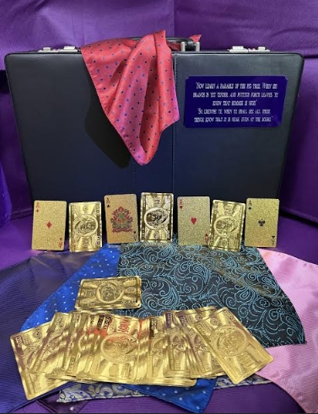
The Welcome package includes.
Company shirt
Company Bracelet
Company Notebook
Briefcase – Paid shipping and handling
Sign and Date all 3 pages. Money Order or Cashiers’ Check for $397. Make out to & Mail to:
Please Allow up 20 Business Days to Receive your Welcome Package
Sign and Date ___________________________________________________
First Name & Last Name _______________________________________________________
Address _________________________________________________________
City, State & Zip _______________________________________________________________
Email Address ____________________________________________________________________________________
Phone# ________________________________________
Date of Birth _______________________________ Male ________ or Female_________
ALL RIGHTS RESERED MAY 2025 AIR ‘MONEY, CEO

COACH NOTES

